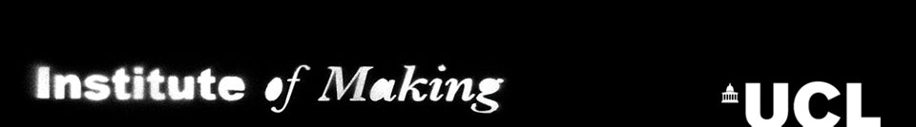

Experimental Laser Cutting
1st October, 2014
Application Form

Have you always wanted to experiment with the potentials of the laser cutter, do you have a project that you would like to give a go?

Come along to explore the potential of laser cutting, experiment with an array of materials to see what they might do. The laser cutter can cut, engrave and etch but how can we stretch those possibilities. Can you cook an egg in the laser cutter? Can you cure resins or silicone in the laser cutter? Join us to test, play and experiment.

This class as limited numbers, please complete the application form to tell us why you want to take part and what you would like to experiment with in the laser cutter.

This workshop is free, and all materials will be provided. Applicants need to be inducted members of the Institute of Making and have completed their laser cutting induction.
To apply for a place: please complete the following form, and return to events@instituteofmaking.org.uk
Deadline for applications 22nd September
You will be notified whether you’ve got a place by 26th September
All applications will be considered, though we cannot guarantee all will get a place. Applications will be looked at by the Institute of Making committee, who will be looking for commitment to laser cutting, have a clear idea of how this workshop will aid further experiment and projects.

Member Name:

UPI number:

UCL Department:

UCL email address:

Have you completed your level 1 Institute of Making induction (ie, does your UCL card work on our door)?

Have you completed your laser cutting induction at the Institute of Making?

What would you like to do on the laser cutter?

How would attending this workshop benefit you?

